**Selenium Test Plan and Cases**

By Sanket Prabhu (srp140430)

Table of Contents

1. Test Plan and test cases 3

1.1 Test Plan 3

1.2 Test coverage: 3

1.3 Test methods: 3

1.4 Test responsibilities: 3

1.5 Test Scenario 3

1.6 Test cases screenshots 4

1.6.1 Test Case-I (Login) 4

1.6.2 Test Case-II (Logout) 6

1.6.3 Test Case-III (Registration) 6

1.6.4 Test Case-IV (Advisor availability) 9

1.6.5 Test Case-V (Add/delete Appointment by user) 10

1.6.6 Test Case-VI (Cancel scheduled appointment by advisor) 12

1.6.7 Test Case-VII (Change of track) 13

# Test Plan and test cases

## Test Plan

I have designed system similar to UTD eLearning where Admin can add students, add courses and tracks students can login into their portals and can register for courses. Advisor can give its availability and student can schedule/cancel an appointment. Admin can add/update delete courses, users as well as track. I am giving test plans using three points as shown below:

## Test coverage:

Our system is really large. But in this exercise, we are planning to test 6 parts such as user login, logout, user registration, add User, daily availability, schedule and cancel appointment by user and cancel scheduled appointment by Advisor.

## Test methods:

We are using Selenium testing tool to create test cases for different scenarios such as Login, Logout and Add user function. We are using Firefox with selenium IDE extension to derive test cases.

## Test responsibilities:

We are performing these test cases to test three major functionalities of our system. Login phase and logout phase are important phases. To get those functions right we are deriving test cases to test systems so that deliverables would have minimum faults.

## Test Scenario

|  |  |
| --- | --- |
| Test Scenario | Expected Result |
| User with valid username and password should be allowed to login. | User should be displayed home page of their own portal. |

|  |  |
| --- | --- |
| Test Scenario | Expected Result |
| User with invalid username and password should not be allowed to login | User should be displayed an error with Invalid Username/Password |

|  |  |
| --- | --- |
| Test Scenario | Expected Result |
| User should not be logged off until he clicks logout or terminates his session by closing browser. | If user accidently closes browser, and he visits same url, then system should redirect him to login page. |

|  |  |
| --- | --- |
| Test Scenario | Expected Result |
| User should be allowed to log out of their system. | If user clicks on Logout button, then system should log out, kill that particular session and redirect it to Login page. |

|  |  |
| --- | --- |
| Test Scenario | Expected Result |
| Admin can add and edit user | Admin can login using his credentials and he can add and edit users by putting user information and clicking on Add User. |

|  |  |
| --- | --- |
| Test Scenario | Expected Result |
| Advisor can give availability, and view/cancel daily appointment | Advisor can login using credential and give availability as well as view and cancel daily appointment. |

|  |  |
| --- | --- |
| Test Scenario | Expected Result |
| User can change his track | User can login and select change track hyperlink. System will show preview and he needs to press yes to make changes and track of users will get changed. |

## Test cases screenshots

## Test Case-I (Login)

Login:

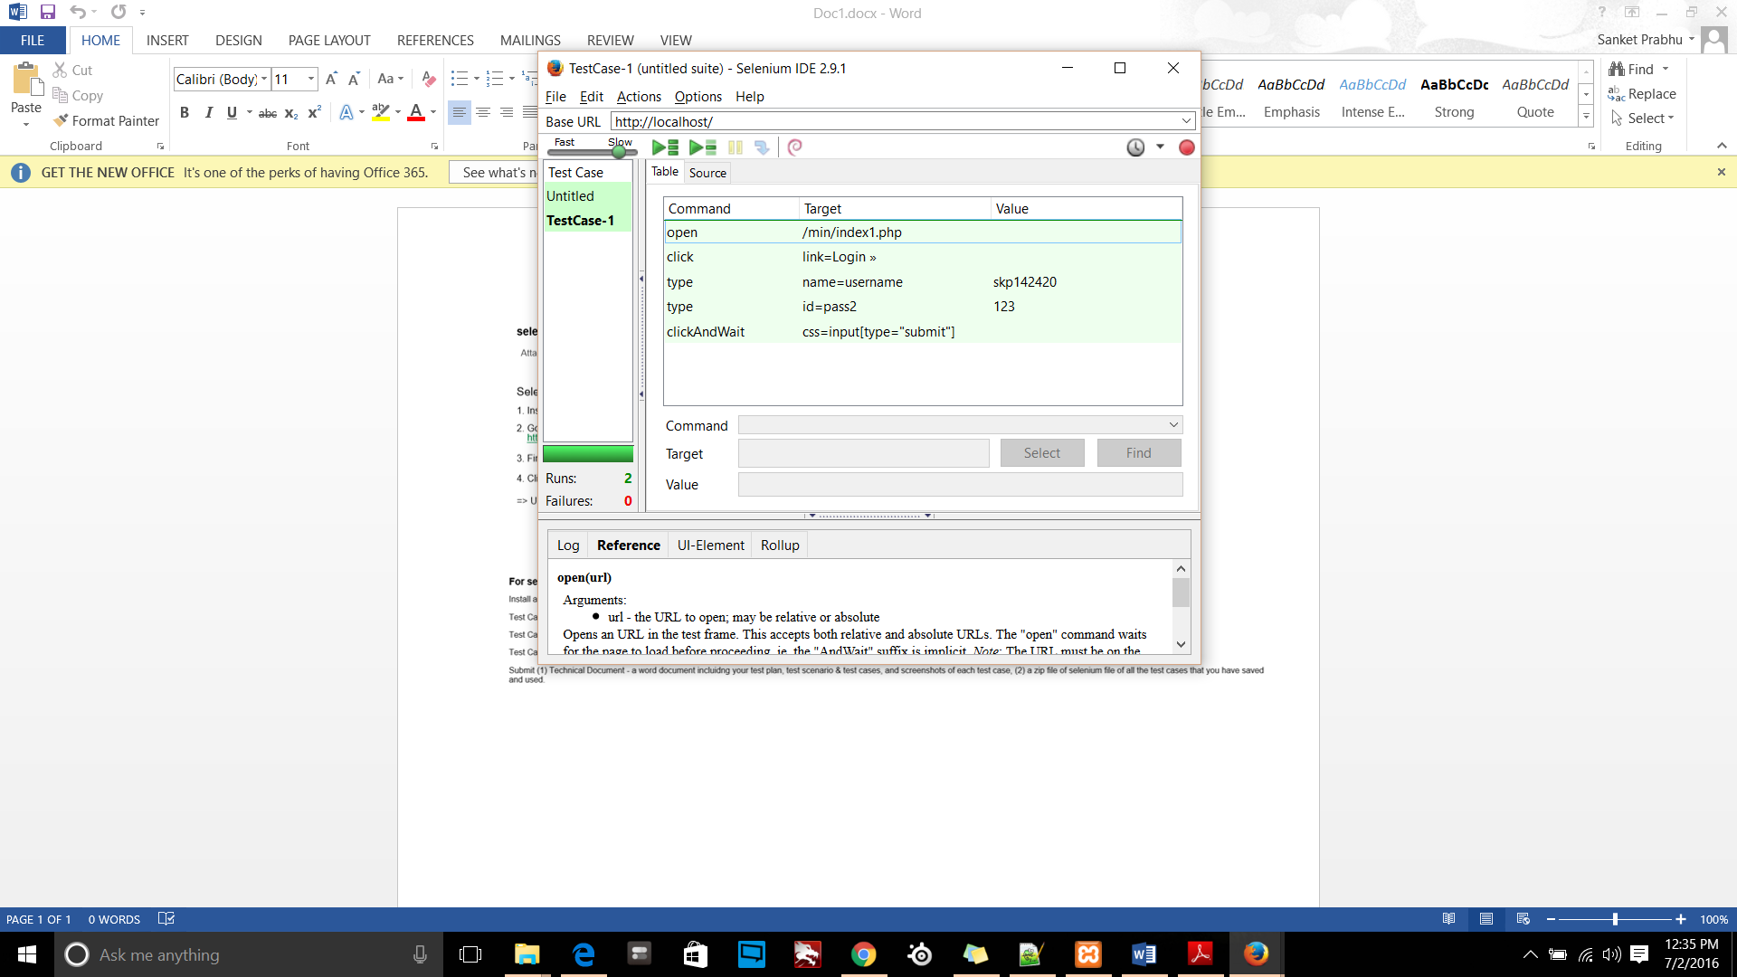

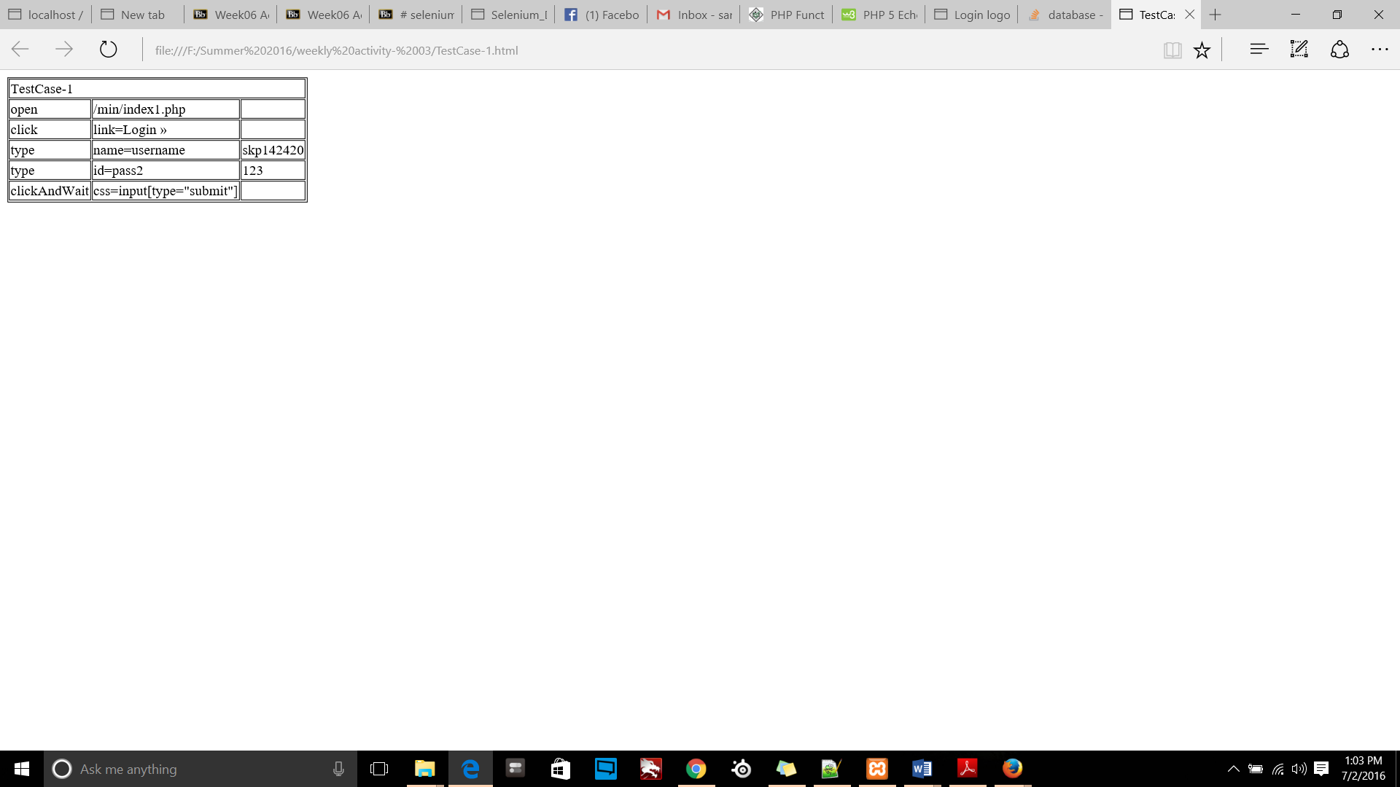

## Test Case-II (Logout)

Logout:

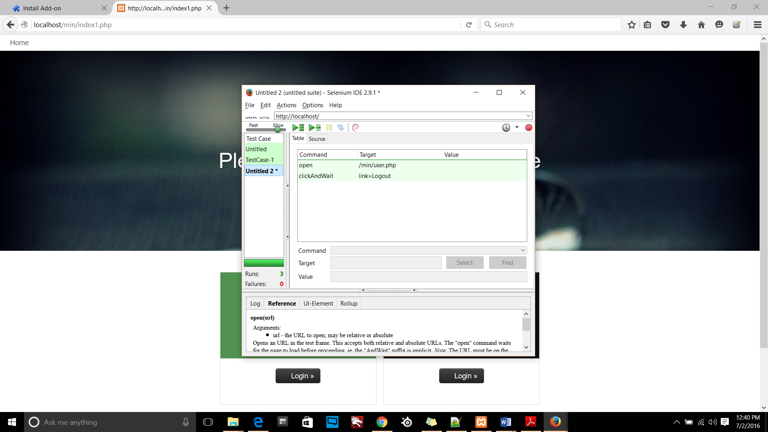

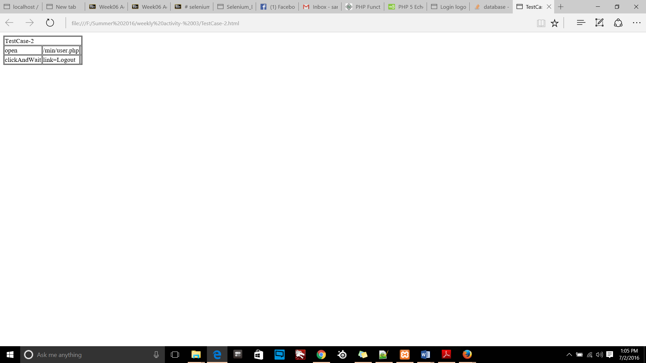

## Test Case-III (Registration)

User registration

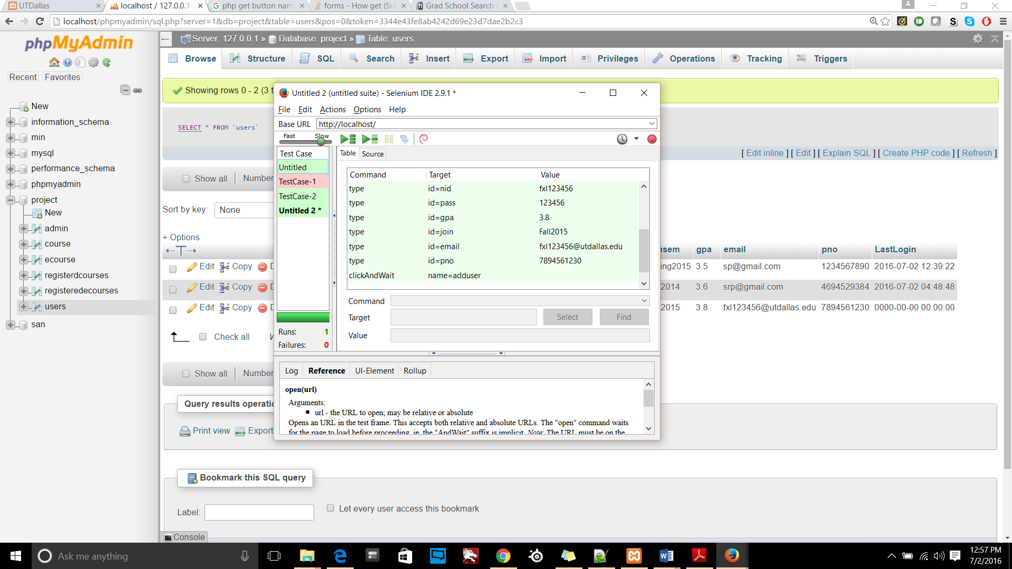

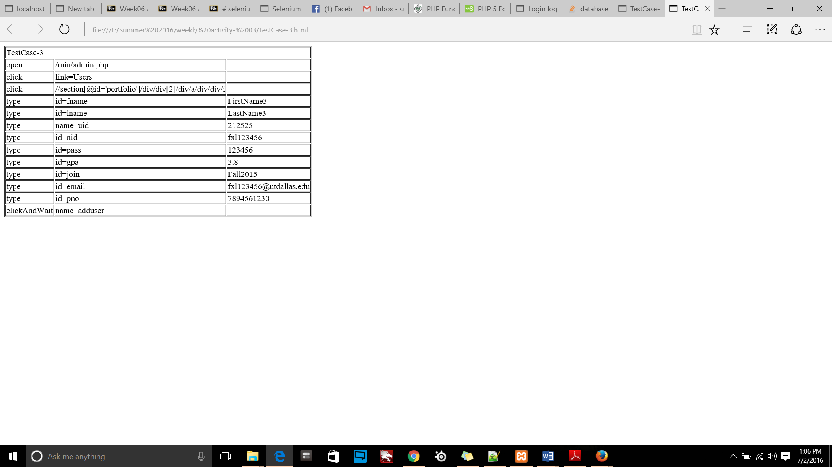

Course registration:

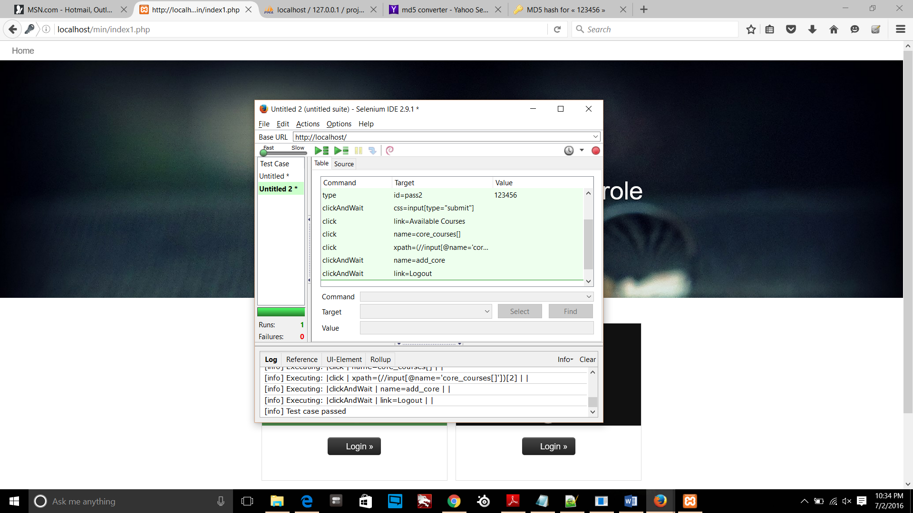

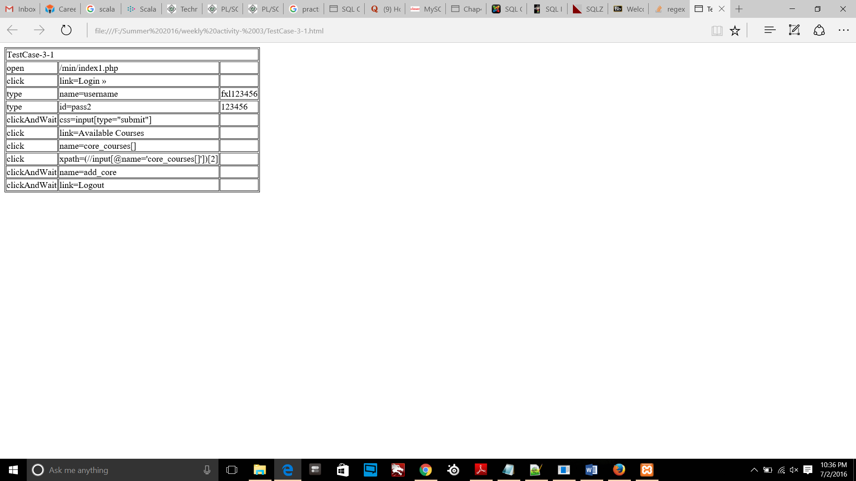

## Test Case-IV (Advisor availability)

Add timeslot as per availability for an advisor:

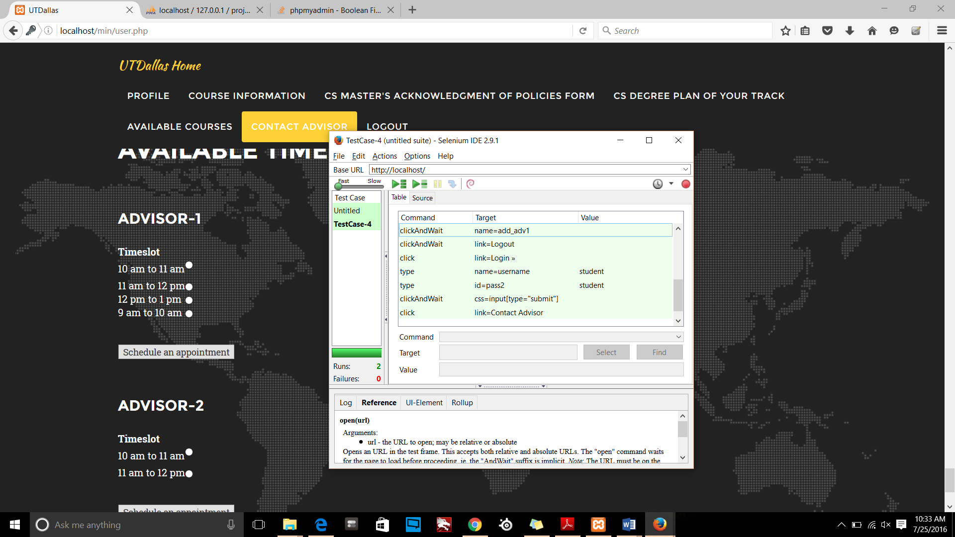

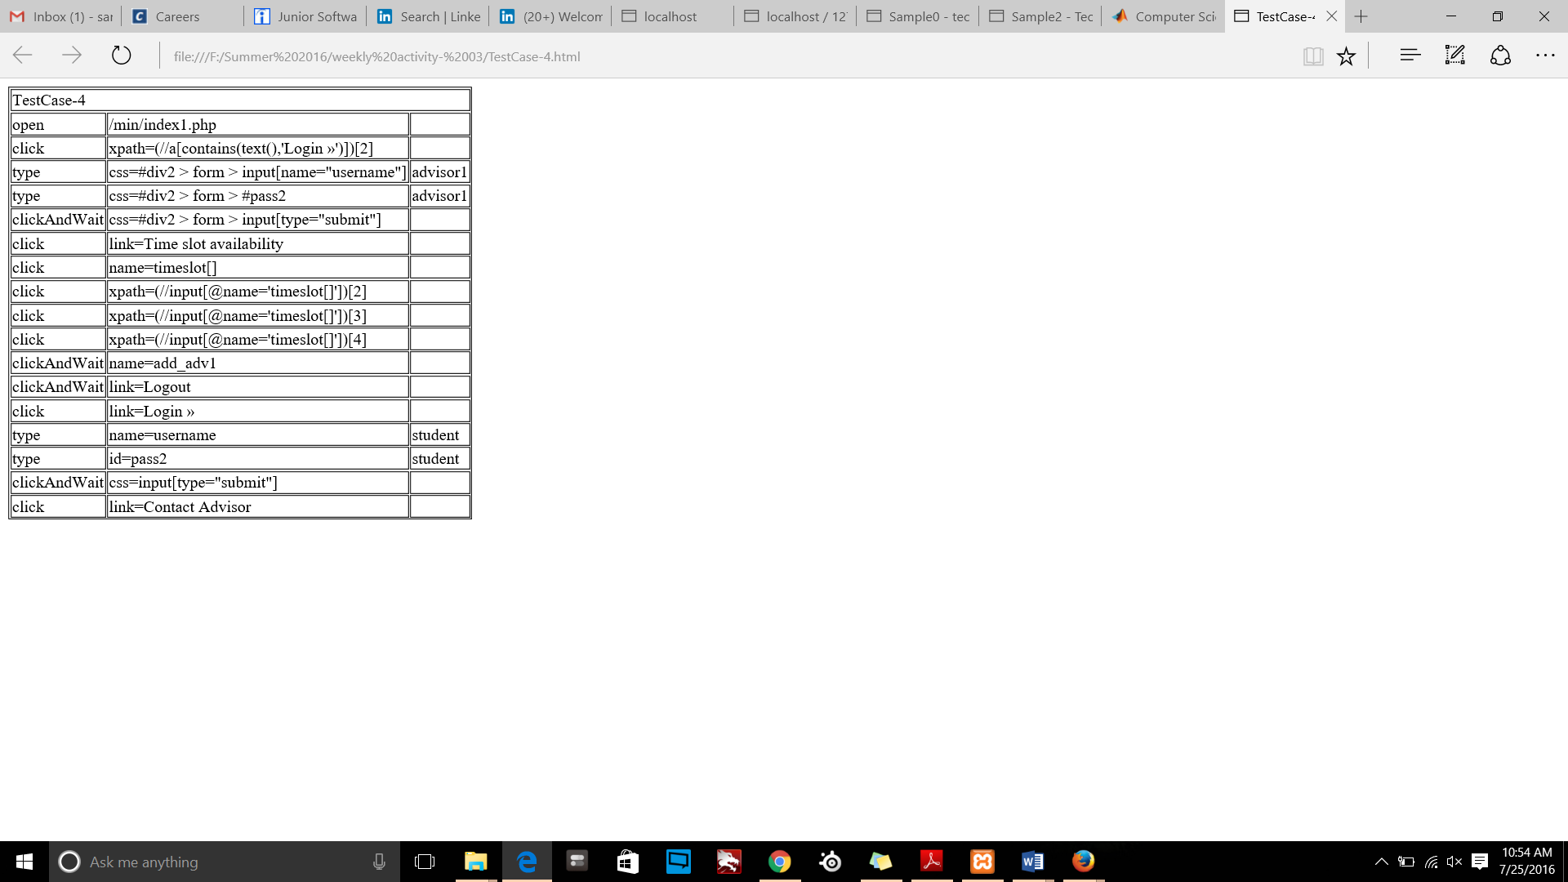

## Test Case-V (Add/delete Appointment by user)

Add/delete appointment by user

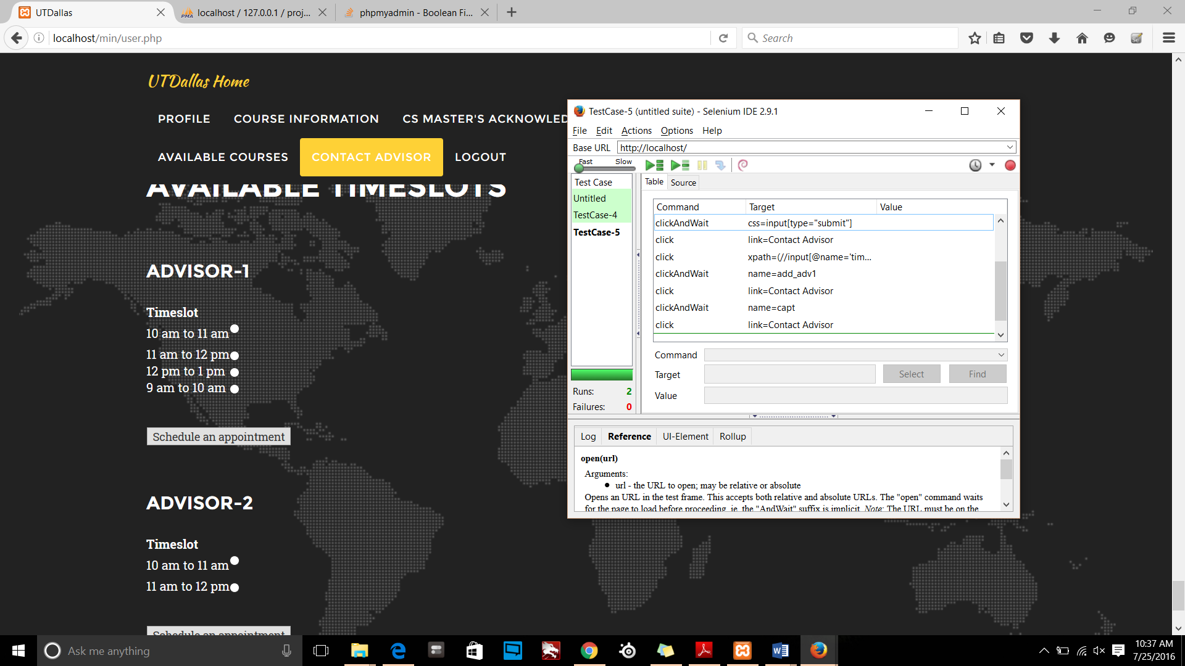

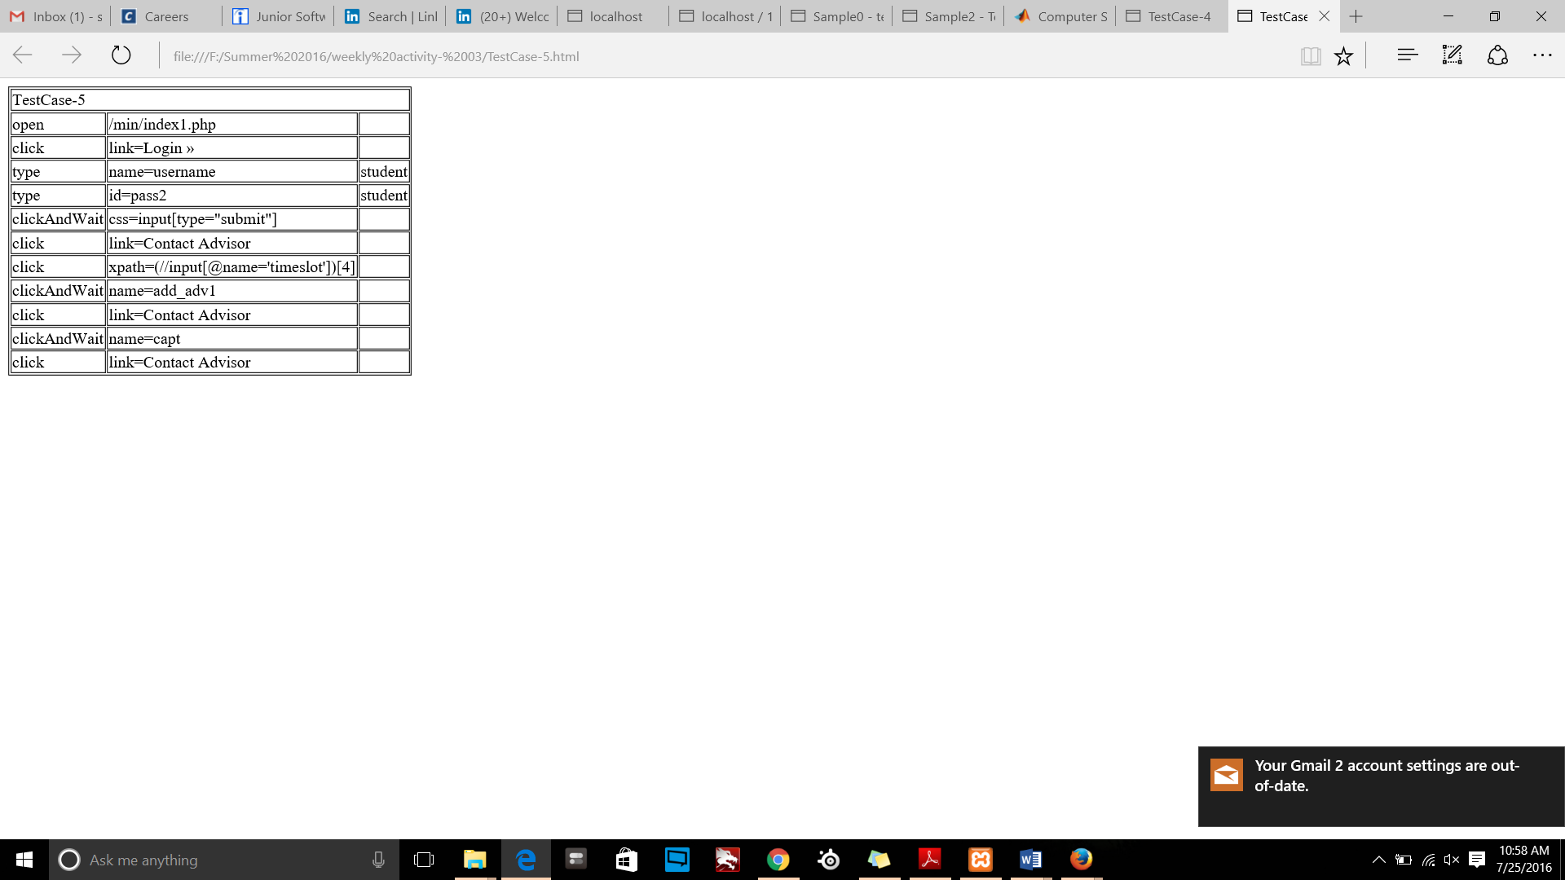

## Test Case-VI (Cancel scheduled appointment by advisor)

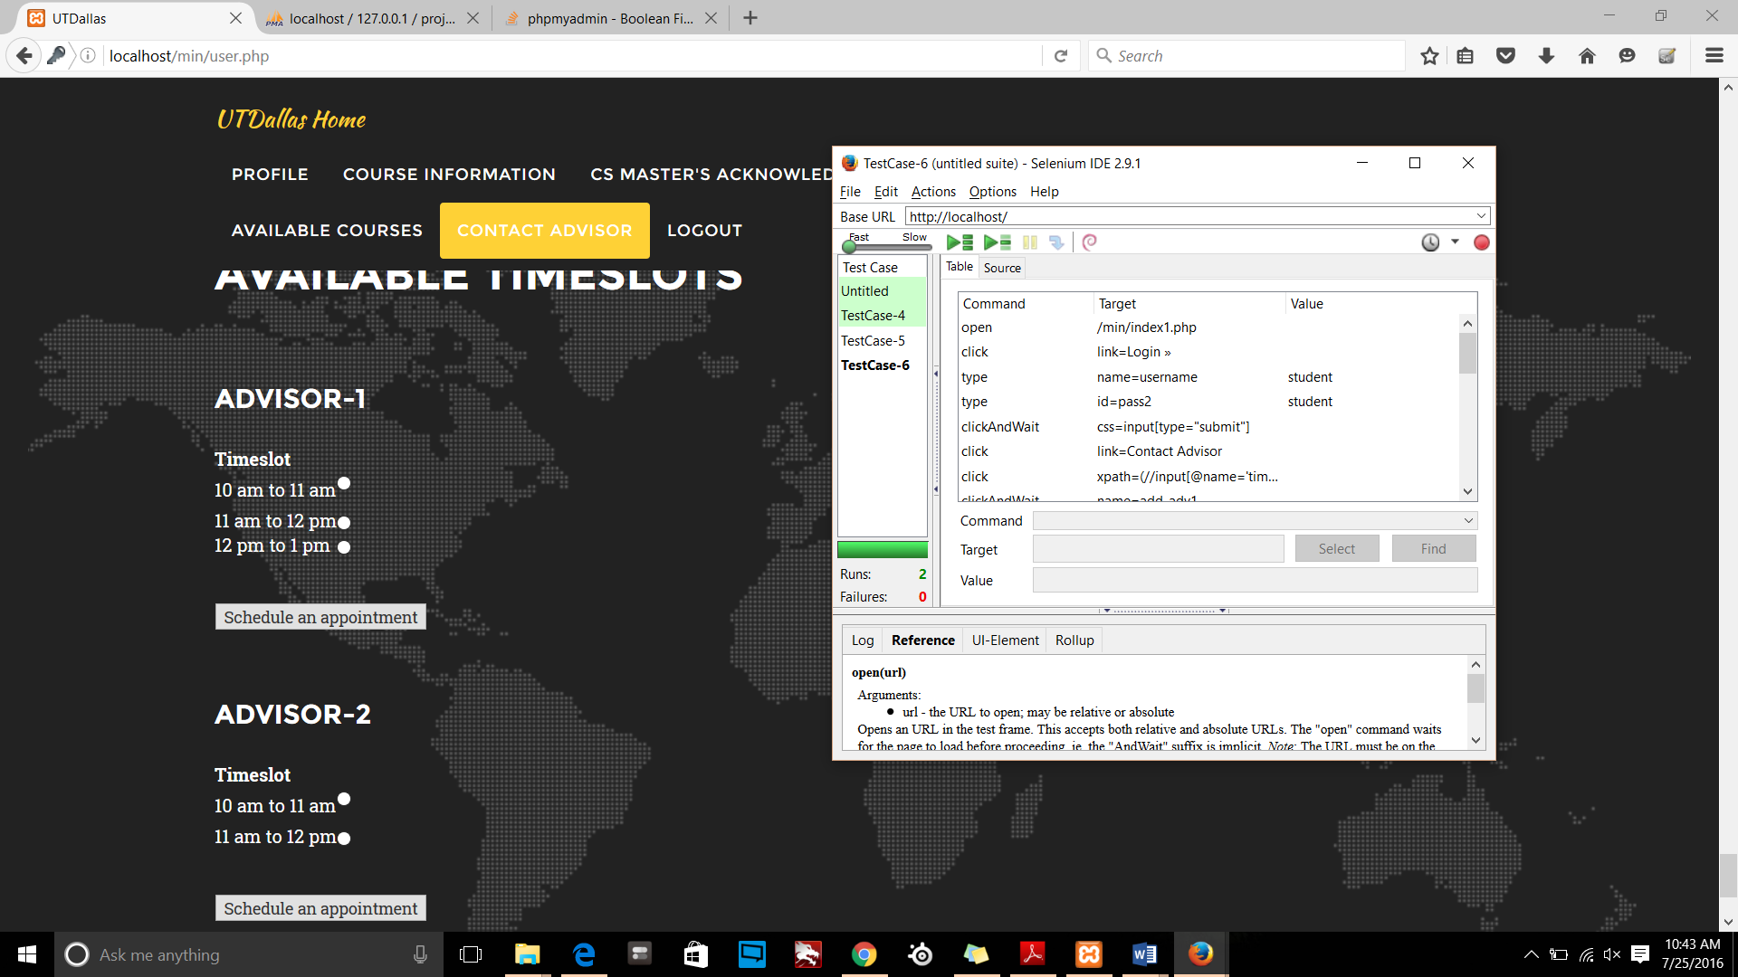

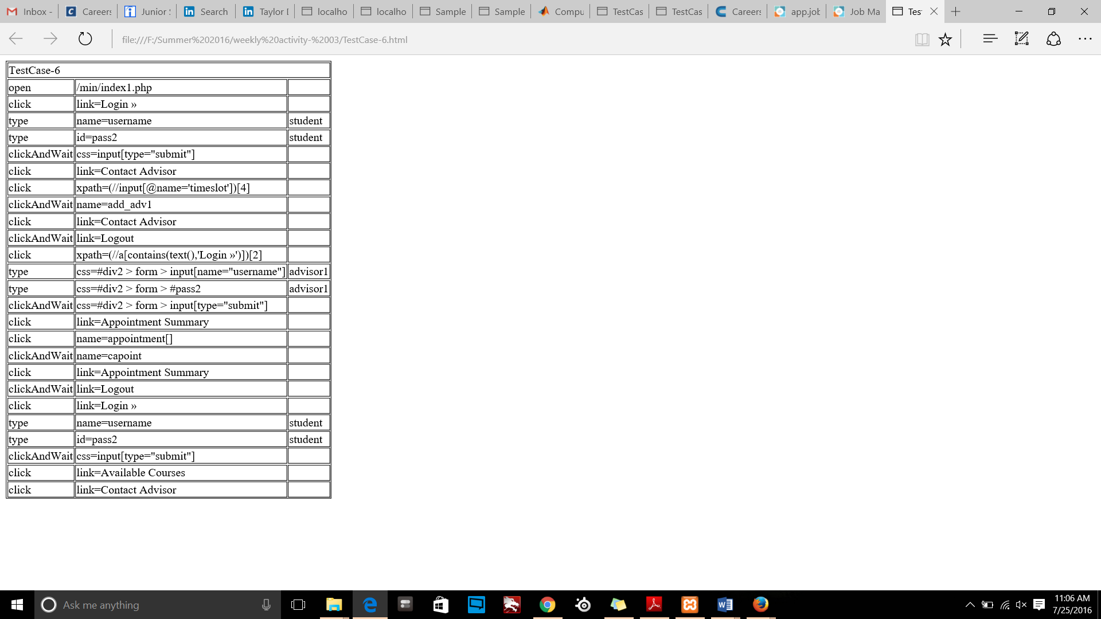

## Test Case-VII (Change of track)

Change track:

